PathDxf2GCode

Utility for graphical definition of milling paths

H.M.Müller, 2026-10-03

Translated with support by https://DeepL.com
Contents
1. Problem 4
2. Manufacturing process 5
3. Solution concept 6
4. User documentation 7
4.1. Main process 7
4.1.1. Designing components 7
4.1.2. Constructing the project 7
4.1.3. Exporting path files 7
4.1.4. Generate G-code 8
4.1.5. Milling 8
4.2. Path drawings 8
4.2.1. An example 8
4.2.2. Path names 10
4.2.3. Path layers 10
4.2.4. Structure of a path construction 11
4.2.5. Parameter texts 12
4.2.5.1. Structure of parameter texts 12
4.2.4.2. Assignment of parameter texts with overlapping only 12
4.2.5.3. Some problematic cases and solutions 12
4.2.5.4. Assignment of parameter texts with parameter text layers 13
4.2.6. Geometry of the milling parameters 14
4.2.7. Paths 15
4.2.8. Specifying path parameters with a @ reference 16
4.2.9. Sweeps 17
4.2.10. Milling chains and milling segments 17
4.2.11. Drilled holes 18
4.2.12. Helical circles 18
4.2.13. Support bars 19
4.2.14. Sweepless milling („slow milling“) 20
4.2.15. Subpath embeddings 20
4.2.15.1. Milled subpath embeddings 20
4.2.15.2. Restricting called subpaths 21
4.2.15.3. Embedding without milling for “correction milling” 22
4.2.16. Subpath embeddings with variables 22
4.2.16.1. Example for a combined clamping and variables project 22
4.2.16.2. Definition of variables 24
4.2.16.3. Usage of variables 25
4.2.16.4. Setting the values 25
4.2.16.5. Check values for variables 25
4.2.17. Star-shaped paths 26
4.3. Component path DXF files 26
4.4. Projects 27
4.4.1. Project numbers 27
4.4.2. Project path drawings and subpaths 27
4.5. Z-Probes 29
4.5.1. Basics 29
4.5.2. Path drawing with Z probes 29
4.5.3. Measuring run 30
4.5.4. Creating the _Milling.gcode file 31
4.6. Calling PathDxf2GCode 31
4.6.1. Command line options 31
4.6.2. Problems and their solutions 32
4.6.2.1. „Path definition … not found.“ 32
4.6.2.2. „End marker missing.“ 32
4.6.2.3. “S value missing.”, “B value missing.”, ... 32
4.6.2.4. „No further segments” at the specified point.“ 32
4.7. Calling PathGCodeAdjustZ 32
4.7.1. Command line options 32
4.7.2. Maximum Z correction 33
4.7.3. Emitting statistics lines 33
4.7.4. Problems and their solutions 33
4.7.4.1. “Line does not have the format ‘(comment) #...=value’” 33
4.8. Milling run 33
5. Program documentation 34
5.1. Overview 34
5.2. Github project 34
5.3. Compiler passes 34
5.4. Basic data structures 34
5.5. Special data structures and algorithms in PathDxf2GCode 35
5.5.1. GCodeHelpers.cs 35
5.5.1.1. Optimize 35
5.5.2. MillGeometry.cs 35
5.5.3. Params.cs 35
5.5.4. PathModel.cs 36
5.5.4.1. Inner class RawPathModel 36
5.5.4.2. Inner class Collection 36
5.5.4.3. CollectSegments 36
5.5.4.4. NearestOverlapping<T>, NearestOverlappingCircle, ….Line, ...Arc, CircleOverlapsLine, ...Arc, DistanceToArcCircle, GetOverlapSurrounding 36
5.5.4.5. CreatePathModel 36
5.5.4.6. CollectAndOrderAllZProbes 36
5.5.5. PathSegment.cs 36
5.5.5.1. Internal RawSegment classes 36
5.5.5.2. MillChain.EmitGCode 37
5.5.5.3. HelixSegment.EmitGCode 37
5.5.5.4. SubPathSegment.EmitGCode 37
5.5.6. Transformation2.cs 37
5.5.7. Transformation3.cs 37
5.6. Special data structures and algorithms in PathGCodeAdjustZ 37
5.6.1. ExprEval.cs 37
5.7. Currently known or suspected problems 37
5.8. Missing features 37
6. Tables 38
6.1. Parameters 38
6.2. Line types 39

1. Problem
A CAD program is typically used to design the results of a manufacturing process. In a subsequent (or parallel) step, one must then also describe that process itself, which might require additional designs—for example special tools, intermediate manufacturing results or, in the case of CNC manufacturing, „CNC programs“ that control the movement of such machines.
Nowadays, the construction typically results in a DXF file, which must then be converted to a G-code file. Of course, this conversion depends on the specific manufacturing process. Among other factors, one has to consider
- the type of CNC machine
- its properties
- the materials used
- the necessary manufacturing precision:
For the same final result, a 3D printer needs a different G-code file than a CNC milling machine or (if manufacturing is possible with it) a CNC lathe. But not only the machine is relevant: If a CNC milling machine is to mill a component out of block material, different G-code is required than for manufacturing from profiles. Finally, many specific parameters of a CNC machine determine the creation of correct and efficient G-code.
The basic question I had to answer for my mechanical designs was, then: Could I use a standard program for G-code creation, or would I need a homegrown solution?

2. Manufacturing process
To answer the question at the end of the previous section, it is necessary to talk about my manufacturing process, which is once again influenced by the final results I want to manufacture. Here are relevant properties of this process:
- I want to build special mechanical models which are assembled from somewhat standardized components.
- Due to the fact that the number of component designs is quite large (100s), I do not want to mass-produce them; rather, after designing a specific model from the components, they are specifically manufactured for that model.
- The components are milled from a few types of aluminum profiles (angle profiles and flat sections). The resulting G-code must be based on milling these profiles.
- Most components are quite small (about 100 mm in length, often below 50 mm). One milling run on the CNC router can therefore create a medium number (10...30) of components. Thus, the G-code program for a single run must be assembled from the designs of multiple components.
- Some components need two milling runs; e.g., components milled from an angle profile require a separate run for each side of the profile.
- In rare cases, it is necessary to change the milling bit between two runs on the same components (e.g. if both a straight bit and a T-slot bit are necessary).

3. Solution concept
Above all, the profiles that I want to use on my CNC milling machine are specific to my designs. There are certainly professional G-code generators that can be taught to use profiles; I'd rather not know the license costs on the one hand, and the configuration effort on the other ... (which may be wrong, because I'm overlooking an elegant solution; nevertheless, I'll take a chance; I could perhaps do some further research here: How to Convert DXF to G-code: 4 Easy Ways | All3DP).
Moreover, I only trust automatically generated G-code to a limited extent. Later, when I really understand the behavior of my machine, I will get involved—but for now I want to have every movement of the machine “specified by myself”.
That's why I've made my decision: I want to write the G-code generator myself.
However, I don't want to use more or less “intelligence” to back-calculate the milling paths from the final description of a component: I want to design these paths by hand too, using the same CAD tool that I use for component design:
- Primarily because it is easier;
- but also because of the aforementioned “full control” requirement.
The rough requirements for my manufacturing process and then the G-code generator look like this:
a) Representation of all path elements required for the milling paths in the CAD program; currently these are:
- straight segments,
- circular segments and
- drilled holes.
b) Representation of all values required for the milling paths (e.g. depth of a hole, height of a sweep) via parameters of graphic objects that
- can be easily specified via the CAD program,
- are visually distinguishable there; and
- can be read stably by the program from the generated DXF file;
c) for each path, the addition of start and end points and a readable designation that can be used to link paths in a compound drawing.
What I do not require is adaptability to different cutter diameters: the path must be redesigned for a different cutter.
The following two chapters describe
- the process to generate the G-code files from a user perspective (chapter 4);
- and then the internal structure of the G-code generator (Chapter 5).

4. User documentation
Remark: In the following I will use „you“ when something is done by, well, you (or some other person); and I will use passive when the program does something. „You create a file“ is done by a person, „a file is created“ is done by a program.

4.1. Main process
The design and manufacturing process with PathDxf2GCode is as follows:

4.1.1. Designing components
You construct the components. You designate these construction layers with numbers without letters at the end, e.g. 2913 or 2913.4.
After this, you create separate path drawings for each “path dimension”, i.e. multiple milling runs for a project on the same parts. As a rule, only one path drawing (one mounting) is required for components made of flat profiles, while two path drawings are required for components made of angle profiles (which I usually designate as L and R). Several path drawings are also necessary for components that require several different milling cutters (e.g. wheels with a groove created with a T-milling cutter).

4.1.2. Constructing the project
For my mechanical models, I will create a group of components together in one milling pass. Therefore, a compound project design is required that connects the milling paths for all these components.
For this purpose, you create project path drawings for each path dimension, which collect the respective paths of all components to be produced on the sacrificial plate (mounting plate) and link them together consecutively for a milling run. The project path drawings also show the dimensioned arrangement of the profiles on the mounting plate as well as the position of the milling coordinate check point and origin.
If you create only one component, the component path file is sufficient as input for the G-code generation.

4.1.3. Exporting path files
You export the path drawings as DXF files. The directory structure can be arbitrary (see also /d parameters on p. 31), but two structures have proven themselves in practice:
- For projects without pre-constructed components, a new directory is created, usually with the date in the directory name. All necessary path files are stored there.
- For pre-constructed components and projects assembled from them, you create
  - the component paths in a component directory (or a few),
  - the project path drawings in a project directory as above.
For each DXF file, you also create and store a corresponding PDF file. You need this for preparing and mounting the profiles, checking Z probe positions and overall visual control of the milling process.

4.1.4. Generate G-code
You call PathDxf2GCode for each exported DXF file (see p. 31). The result is a G-code file with the same name but with file extension .gcode.
If errors occur during conversion, you must correct the path construction in the CAD program (see p. 32) and export it again.

4.1.5. Milling
For each G-code file you
- mount (or remount) the profiles accordingly (you can use the exported PDF files with the material descriptions and dimensions for this manual step),
- set the coordinate origin of the milling machine,
- and finally start the milling process.

4.2. Path drawings
You create path drawings for individual components. If—as described on p. 7—you combine these into projects, you also have to create path drawings for the projects (which then contain partial path embeddings for the components—see p. 21). This section describes the general elements of path drawings; their use is described in separate sections on components (p. 26) and projects (p. Fehler: Verweis nicht gefunden).

4.2.1. An example
Here is an example of a construction—in this case a component (drawing no. 2050+2051 K; K stands for “construction”):
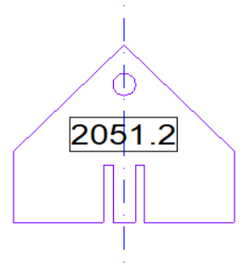
The drawing for the associated milling path (here a component path) looks like this (drawing no. 2051 P1; P is the abbreviation of “path”):
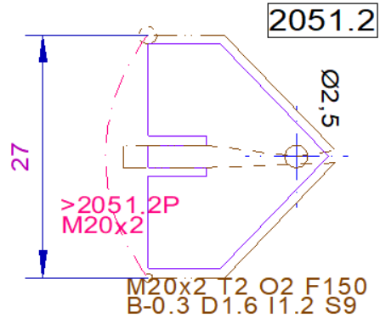
Some important elements of each path are directly recognizable here:
a) The start of a path (under the text M20x2...) is marked by a small circle with a diameter of 1mm. A number of parameters must be specified there, including the material (flat stock with dimensions 20x2), the upper edge of the profile (here T2 = 2 mm above the zero plane), the cutter diameter (O2=2mm) and others.
The basic idea is that all essential parameters for milling are described at this one point.
b) For contour milling paths—especially on straight edges—the component path is drawn along the component at the radius distance of the milling cutter (here 1 mm, due to the 2 mm end mill).
c) Holes are drawn in the path with their actual diameter (the example shows a 2.5 mm hole at the tip of the component).
d) The end of the path is marked by a circle with a diameter of 2 mm.
e) The start and end markers are arranged so that the component path can be “stacked”: A copy of the component path—or another path for the same profile—can be placed with its start point on the previous end point. This enables simple construction of the project path drawings (see p. 27).
f) A dash-dotted proxy line (_ . _) from the start to the end circle is intended to be copied into a project drawing using this component. The proxy line can be a straight line or an arc, whatever is more pleasing visually. The > sign in front of the path name is explained in the section on subpaths (see p. 21). Further path parameters are specified on the line, which are used to check the embedding in project path drawings (here, a material specification indicated by M).
g) Line types indicate the type of movement:
- ____ Continuous line = milling (milling movements)
- _ _ _ Dashed line = do not mill (sweep)
- _.._.._ Dash-double dotted line = half milling; common uses are:
  - At the edges where the profile continues, this prevents it from being “milled off” and thus losing the mounting. In the example above, this can be seen at the top and bottom of the non-beveled segments.
  - In other places, it is used to mill “markings” into the material for subsequent processing—in the example for the narrow slots to be made with the band saw for the key tube to be inserted.
- _ _ . _ _ Double-dash dotted line = support bar milling; see p. 20.
h) The path diagram contains dimensions of the external dimensions in order to estimate how much material is required and to ensure that the component can be placed within the working area of the milling machine.

4.2.2. Path names
Each path must have a name that matches the path name pattern passed with option /n. The default value for this option is ([0-9]{4})[.]([0-9]+)([A-Z]), thus a standard path name must consist of three groups, with a period between the first two:
4-digit-number . number uppercase-letter(only A-Z)
Two allowed path names that match this pattern are 1234.1A or 2055.999B. Path names which are not allowed are e.g. 2345 (period and rest is missing), 3456.9 (uppercase letter is missing), 4567.8Ä (umlauts are not allowed) or 5678.9AB (two letters at the end).
For specific mapping purposes, path names can be supplemented with a tilde ~ and one or more letters; see p. 13.
At the end of a path name, you can append a # character followed by any text. The text following the # character—and any preceding spaces—is ignored. Such additions can be helpful in the CAD program to supplement numerical path names with descriptive explanations, e.g., 1234.1A # front frame; this is completely equivalent to 1234.1A or 1234.1A # frame in front.
You can use the options /n and /p to specify other path name patterns (see p. 31). The patterns must correspond with each other, as they are used to find the DXF files that contains paths in subpath embeddings (for details, see p. 21).

4.2.3. Path layers
What is not directly visible in the path drawing: The path lines and markings (but not the representative line for naming—see p. 21) must be on a layer that is named with the path name, in this case 2051.2.
As quite a few layers are created in a CAD file in this way (one for each milling path, i.e. usually one or two for each component), these path layers must be organized sensibly. I follow the following structure:
- There is a main layer „Pfade“ („Paths“).
- A path drawing for the designs of drawings 1234 K receives a parent path layer 1234.** under “Pfade” (the two asterisks indicate path layers, in contrast to construction layers, which are grouped under 1234.*). If a drawing comprises several drawing numbers, e.g. 1234 K and 2345 K, separate construction path layers 1234.** and 2345.** are created for them.
- The component path layers for e.g. components 1234.1, 1234.2 etc. are located below the respective parent path layer. For components with only one path layer, the component path layer is named 1234.1P; for components made of angle profiles that require two layers, 1234.2L and 1234.2R are used. In other cases (e.g. several paths due to tool changes), other letters can also be appended. Layer names without letters at the end (e.g. 1234.1) are reserved for the construction layers.
The path can be checked visually by displaying only the component path layer. For the component above it looks like this:
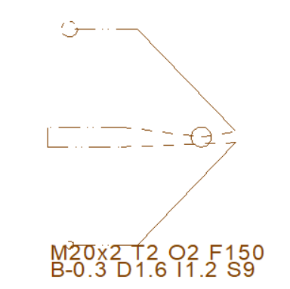
I place the proxy path (the dash-dotted line) in the **-path layer of the component (one could place it in any layer; when copying to a project path drawing, you have to place it in the project path layer there anyway).

4.2.4. Structure of a path construction
Following the exemplary overview in the last sections, here is a complete description of how a path construction must be structured so that it can be processed by PathDxf2GCode.
Each path construction has the following structure:
Path with start and end markers and the following path elements:
    - Sweeps
    - Milling chains with
    - milling segments: Straight lines and arcs, either full-depth or half-depth
    - Drilled holes
    - Helical circles
    - Subpath embeddings
    - Z Probes
Paths and their elements have parameters that control milling. For example, milling segments have a milling depth, milling chains have an infeed, helical circles have a diameter. Some of the parameters are specified directly geometrically (such as the hole diameter), others are determined by texts that lie above the respective element (see p. 12).
Some parameters can be inherited via the path structure. For example, the milling depth for an entire component can be determined for the path; however, if individual holes are to be milled as blind holes, the milling depth can be changed locally.
The following sections describe the path elements and their parameters as well as the options for defining them in detail.

4.2.5. Parameter texts

4.2.5.1. Structure of parameter texts
Formally, a parameter text consists of a sequence of parameter definitions, each of which consists of a parameter letter and a value. There must be no space between the letter and the value; the individual definitions are separated by line breaks or spaces. If a value becomes very long (this can easily happen with variable definitions; see p. 24), it can be broken up with a tilde (~) and possibly a space, e.g. here in the definition of the value list for the variable L:
O2 T2
S15 M...x2
:L5,10,15,~
20,25
The anchor point of a text must currently be located
- at the bottom left
- or at the bottom right
- or at the center.
If the anchor is not at the center, the text must not be rotated. Finally, it must not be oriented from bottom to top or from right to left. In practice, it is best to choose the anchor point at the center, because then the center of the overlapping circle of the text does not move when scaling the text, or when the path, together with its text, is rotated by 90°.
The images shown in previous sections show definitions of one (N1), two (>8998.2P M20x0.1) and eight (see the image on p. 11) parameters. Most parameters are numerical values; they can be written with a point or a comma as a decimal separator. Material specifications can be any character string, path specifications after > must correspond to the regular expression for paths (see p. 27).

4.2.4.2. Assignment of parameter texts with overlapping only
Parameter texts must be placed in such a way that they overlap “their element”. Care must be taken to ensure that
- the text is also in the path layer;
- if possible, only one text overlaps the element. However, PathDxf2GCode attempts to resolve multiple overlaps in this way: A text is assigned to the closest circle if possible; if there is no overlapping circle, to the closest arc; if none is found either, to the closest straight line.
- the overlap is wide enough: The overlap is checked by a circle around the center of the text, which, however, does not extend over the full width of the text, especially in the case of wide texts.

4.2.5.3. Some problematic cases and solutions
Here are some examples of problem cases and their solutions:
- In the following example, the text N1 should refer to the line below; however, due to the preference for circles, this only works if the text is placed exclusively above the line, i.e., it does not intersect the circle:
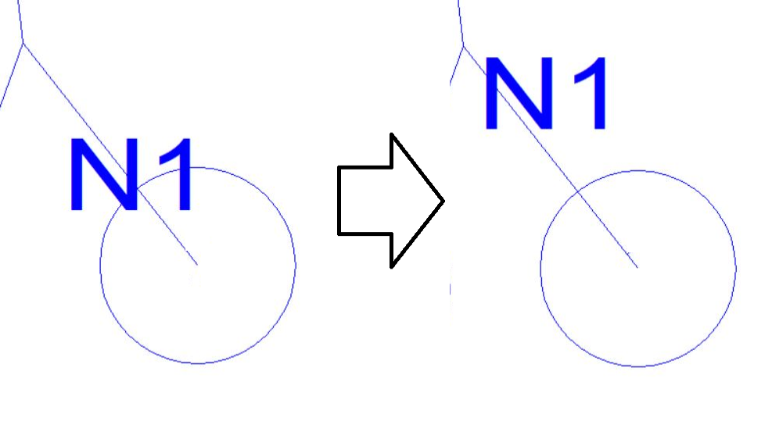
- -The “search circle” (added here by hand) of the following wide text is smaller than the text: Although the P overlaps the line on the right, PathDxf2GCode does not find this assignment. This can be remedied by moving the text slightly to the right:
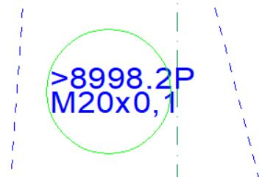

4.2.5.4. Assignment of parameter texts with parameter text layers
In some cases, correct assignment is only possible through suitable overlapping—for example, if a circle is too close to the element that is to be provided with a parameter text. A solution to this is a separate parameter text layer in which both the element and the parameter text are placed. The layer name must be structured as follows:
Path-layer-name ~ Lowercase-letters
Here is an example: The following construction connects a hole with a step that surrounds part of the hole:
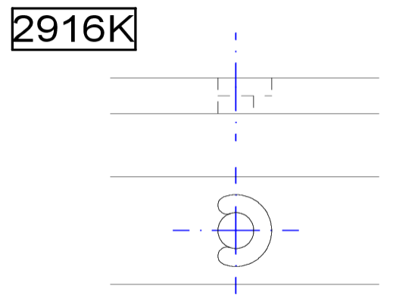
A helix hole and an arc are required as a milling path, whereby the arc is only milled up to the middle of the profile due to the parameter specification B1. In the following drawing, all path segments and also the parameter texts are located on the path layer 2916.1P, which is shown in a red color—including the arc and the text B1. Without a special assignment, the text is “caught” by the circle of the helix hole instead of being assigned to the arc:
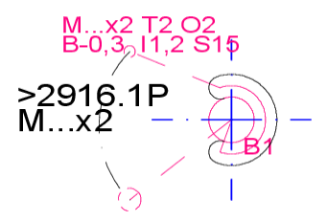
You can see this in the output of PathDxf2GCode with option -x B1:

Object
Circle LAYER=2916_1P CODENAME=CIRCLE TYPE=Circle LINETYPE=…
is assigned text ''B1' @ [77.900|122.750] d=2.343'
This can be remedied by assigning both the arc and text B1 to a separate parameter text layer
2916.1P~A (which is shwon here in the customary blue color). With this, a reliable assignment of the B1 text to the arc is possible:
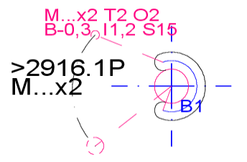
The output of PathDxf2GCode now shows that the text is assigned to the sheet
Object
Arc LAYER=2916_2P~A CODENAME=ARC TYPE=Arc LINETYPE=CONTINUOUS%1 …
is assigned text ''B1' @ [77.900|122.750] d=2.343'

4.2.6. Geometry of the milling parameters
The following diagram shows the geometric milling parameters, which are discussed below. The B value, like all other values, is measured from the 0 height upwards; if “undercutting” is to be carried out as shown here, B must therefore have a negative value:
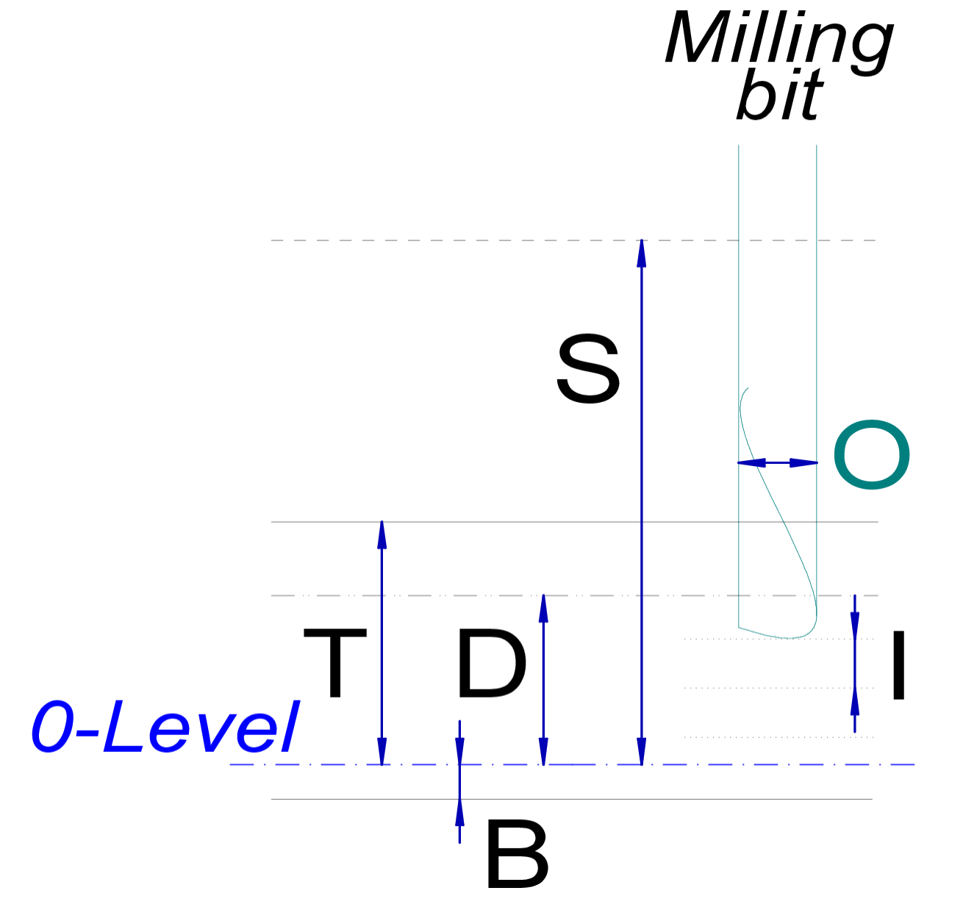

4.2.7. Paths
A path is the basic element for describing a milling process. PathDxf2GCode can only generate a G-code file for an entire path. A path consists of individual path elements that graphically describe the movement of a milling tool. These elements must therefore connect directly to each other, gaps must be bridged by sweeps. The following are permitted as graphical path elements:
- Straight lines (DXF: LINE)
- Arcs (DXF: ARC)
- Circles (DXF: CIRCLE)
Texts (DXF: TEXT and MTEXT) are also used to control the parameters of the elements. All other elements in a DXF file are ignored without an error message. If such other elements (e.g. splines) are parts of paths, PathDxf2GCode does not see a continuous path and the error message “No further segments found after point ...” is usually displayed (see also p. 32).
The start and end of a path must be specially marked. Small circles with line type dash-double dash (DXF: PHANTOM) are used for this purpose:
- The start is marked by a circle with a diameter of 1 mm;
- the end is marked by a circle with a diameter of 2 mm;
The following values can be defined at the start of the path (i.e. in a parameter text above the 1 mm start circle):
- T: Material thickness in mm; mandatory if not specified individually for all segments.
- O: Cutter diameter in mm; mandatory.
- M: Material specification; mandatory.
- F: Horizontal milling speed in mm/min; must be specified either in the path or as command line parameter /f (see p. 31).
- G: Vertical milling speed in mm/min; if missing, the value of the /g option, if this is missing then horizontal milling speed / 4.
- J: Ramp angle in °; must be larger than 0° and at most 90°; default value is the value of the /j option, whose default value is 10°.
- I: Infeed in mm; must be specified either with the path or individually for milling chains and helical circles.
- B: Milling depth (above 0-level); milling segments, helical circles and drilled holes are milled to this depth if no other B value is specified.
- D: Marking depth; marking segments are milled to this depth unless a different D value is specified.
If both B and D are specified, then D must be greater than B. This only serves to ensure that D and B cannot be “misused”: B should always be the “deep milling depth”, D always the “high marking depth”. However, this is not checked when specifying B or D on individual segments (see p. 17)—so you can “play tricks” with B and D there.
- P: Support bar length; see description on p. 20.
- U: Support bar distance; see description on p. 20.
- Y: Clamp clearance; the value T+Y is used as sweep height, unless S is directly specified.
- S: Sweep height; sweeps are made at this height unless a different S value is specified for a sweep or a milling segment. If S is not specified at a path,
  - subpaths use the sum of T and O—the intention is to sweep „a little bit above T“. Make sure that the whole working area of a path is free of fastening objects if you rely on this default. The sum of T and O is also used when the /c command line option is specified (see p. 31);
  - the top level path uses the valud of the /o command line option (see p. 31).
- R: File name suffix; this text is added to the names of the generated files. The purpose is to provide information about the variable assignments in the file name – see p. 25. The default value is an empty text, i.e. the names of the generated files are taken directly from the name of the DXF file.
- Z: Measuring speed in mm/min; if the value is not specified, the current F value ist used (however, this value is typically much too large!).
- A: Greatest helix diameter in mm; if A is not given, the value 4 · O is used. For rationale and usage of this value see p. 19.
- W: First milling depth for sweepless milling (see p. 20). If W is provided at the path start, all straight and arc milling segments are milled sweeplessly (explicit sweeps, however, are done as usual). For the following mill traversals, the milling bit is lowered by the infeed I; thus, a down-mill must be possible, or the lowering—i.e., the start of the milling chain (see p. 17)—must be in an open area.

4.2.8. Specifying path parameters with a @ reference
In many cases, different paths in a drawing have identical parameters, for example the paths on the left and right side of an angle profile, or multiple parts routed from the same profile. In such cases, instead of repeating the parameters at each starting point, one can fully define them at only one path and then reference this path from others by specifying @pathname at their starting poitns. Here is an example:
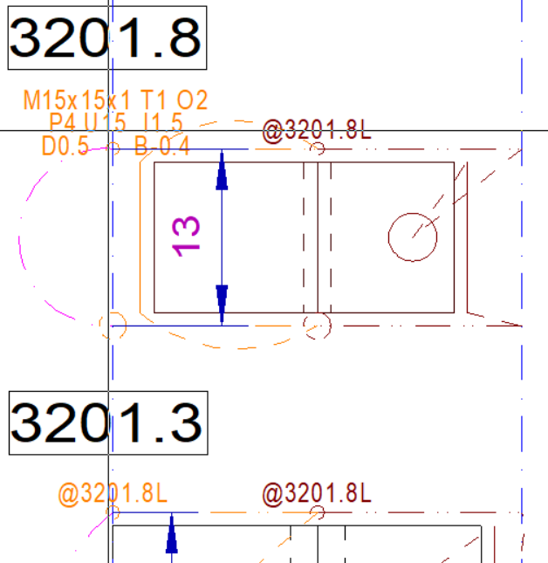
Such a @ reference must not contain other parameters, and the referenced path must be in the same DXF file as the reference.

4.2.9. Sweeps
Sweeps are represented by dashed (DXF: DASHED) or long dashed (DXF: HIDDEN) lines. The following parameters can be specified for dashed sweeps:
- S: Sweep height; if not specified, the value for the path is used.
- N: Sequence for branches; see p. 26.
Long-dashed sweeps do not accept parameter texts. They are helpful in situations where a path construction contains many texts, especially for project constructions, which usually only contain partial path embeddings (see p. 21 and 27).
Sweeps can be drawn as straight lines or as arcs. However, in both cases the milling bit will travel in a straight line from the start to the end point. For quicker operation, multiple subsequent sweeps that are at or above the S height of the complete path (which is assumed to be above all possible obstacles) are aggregated to a single sweep.
The speed of a sweep cannot be defined in the G-code, it is a property of the milling machine. However, PathDxf2GCode needs this speed for the statistics calculation, so it must be specified as a /v command line option (see p. 31).

4.2.10. Milling chains and milling segments
Milling segments are the main “workhorses” of a G-code file. As a rule, several milling passes must be made for each milling segment, in which the milling head is advanced by a small infeed each time. PathDxf2GCode combines consecutive milling segments into milling chains and performs the milling passes for each entire milling chain. Milling segments are only straight sections and arcs; a milling chain ends at drilled holes, helical circles, sweeps, and subpaths. Milling chains can consist of several “branches” (“star chains”), see p. 26.
The milling passes for a milling chain are alternately traversed in forward and backward direction. Segments that have been milled to their final depth are bypassed by a sweep at the current sweep depth.
Between two milling passes, the router head can move in two ways:
- with a vertical bore mill;
- with two ramps, leading in a zigzag path from one pass layer to the next lower one. In general, the two ramps descend with the ramp angle (provided by the /j option or the J parameter). However, if a segment is so short that the next layer cannot be reached with that angle, the ramp is milled steeper, but slower so that the vertical milling speed (/g option or G parameter) is not exceeded.
The optional parameters of a milling chain are specified at the first milling segment; they then apply to the entire chain:
- I: Infeed in mm; if this specification is missing, the I value of the path is used.
- W: First milling depth for sweepless milling (see p. 20); if this specification is missing, but is present at the path start, that information will be used.
Milling segments can be drawn with three line types:
- as continuous lines (DXF: CONTINUOUS); for these milling passes, the milling depth is specified with the B parameter;
- as dash-double-dotted lines (DXF: DIVIDE) for “marking segments”; for these milling movements, the milling depth is defined with the D parameter.
- As ndouble-dash-dotted lines (DXF: CENTER) for milling of support bars; for these lines, the upper rim of the support bars is defined with D, whereas the level of the troughs in between is defined by B. For more information see p. 20.
These two segment types can be used to describe frequent cases of milling operations of different depths without too many individual details, e.g.
- milling of markings
- possibly also millings with retaining bars if no marking millings are required.
The optional parameters for individual milling segments are
- F: Horizontal milling speed in mm/min; if not specified, the specification for the path or, if this is also missing, the /f command line parameter is used.
- G: Vertical milling speed in mm/min; if not specified, the specification for the passed, if this is missing, then the value of the /g option, and if this is also missing, then horizontal milling speed / 4.
- B: (for continuous line) or D (for marking line): Milling depth in mm; if not specified, the specification for the path is used.
- N: Sequence for stars (see p. 26).
- Q: Comment that is written to the G-code file.

4.2.11. Drilled holes
Drilled holes are holes that have exactly the diameter of the cutter (i.e. where the diameter drawn is equal to the O value of the path); they are rarely used. Like milling segments, drilled holes can be drawn either with a continuous line or with a double-dotted line (see p. 17). The following parameters can be specified for drilled holes („FBQ“):
- G: Drilling speed in mm/min; if not specified, the specification for the path or, if this is also missing, the /f command line parameter is used.
- B or D (depending on the line type: milling depth in mm (bottom of the hole); if not specified, the specification for the path is used.
- Q: Comment that is written to the G-code file.

4.2.12. Helical circles
Helical circles are circular millings with an outer diameter larger than that of the milling cutter. The circle drawn indicates the outer diameter of the milling cut; this is helpful for the most common application, milling a hole.
Note: All other milling paths—especially arcs (ARC)—describe the movement of the milling cutter center; only the helical paths draw the outer edge of the milling cut. This is confusing because it is difficult to visually distinguish a (long) arc from a circle. However, I leave it this way because of the frequent use of helical circles for hole milling.
As a precaution against using helical circely wrongly, they can only be used up to a certain diameter—the idea is that only smaller „holes“ should be specified with helical circles, whereas larger circles should be constructed from arcs. The default maximum diameter for a helical circle is 4 times O (the milling bit diameter). If, in special cases, larger helical circles are necessary, one can modify that value with the A parameter at the path level.
Helical circles are milled using a spiral movement, which [currently] always takes place in a clockwise direction (G02). When milling out a hole using concentric helical circles from the inside to the outside, this results in up-cut milling.
If a component is to be milled from the outside and climb milling is to be avoided, then the milling path must be individually composed of arcs that are traversed in the desired direction.
Helical circles can be drawn in the same way as milling segments, either with a continuous line or with a double-dotted line (see p. 17). The following parameters can be specified (“FBIQ/FDIQ”):
- F: Horizontal milling speed in mm/min; if not specified, the specification for the path or, if this is also missing, the /f command line parameter is used.
- G: Vertical milling speed in mm/min; if not specified, the specification for the passed, if this is missing, then the value of the /g option, and if this is also missing, then horizontal milling speed / 4.
- B or D (depending on the line type): Milling depth in mm (bottom of the hole); if not specified, the specification for the path is used.
- I: Height of a helix in mm; if this information is missing, the I value of the path is used.
- Q: Comment that is written to the G-code file.
For helical circles whose diameter is greater than twice the cutter diameter, PathDxf2GCode does not generate G-code for milling away the resulting core—therefore these are circles, and not holes. If it is necessary to mill away the core (for blind holes or to prevent a milled core from jamming or being thrown around), then several helical circles with increasing diameters must be constructed. PathDxf2GCode mills such concentric helical circles from the inside to the outside in any case.

4.2.13. Support bars
PathDxf2GCode can help with a simple milling of support bars: A double-dash-dotted line (DXF: BORDER) results in a toothed milling movement, which can create support bars with suitably chosen parameters.
Support bars are supported for
- straight line milllings
- arc millings
- and helical circles.
The following diagram shows the parameters and geometry of support bar milling:

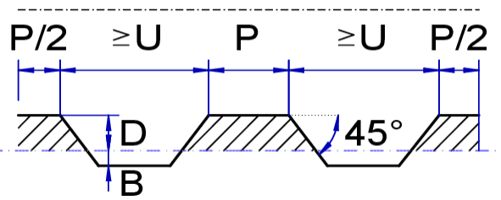
The following parameters must be specified:

- P: Length of the support bars. The two outermost bars are of length P/2 (the reason is mainly that with helical circles, they connect to a full support bar of length P).
- U: Lower bound for distance betweem support bars. PathDxf2GCode will always try to fit in as many equally spaced support bars as possible, but their distance will never be smaller than U.
- B: Milling depth between support bars (typically negative, i.e., belo zero layer).
- D: Milling depth of support bars.
The parameters are typically specified at the start circle, but can be overridden for any support bar line.
Support bars are computed for each double-dash-dotted line separately. It is therefore not easy to get nicely spaced support bars on a complex milling chain that consists of multiple segments. In such cases, the support bars should probably be constructed manually from combinations of milling and marking segments.
The milling movement sfor support bars can of course also be used to mill structures where—with B > 0—material is left also between the „teeth“, resulting in a comb-like pieces.

4.2.14. Sweepless milling („slow milling“)
Sweepless milling for straight segments and arcs is necessary for special milling bits, e.g. T bits which cannot be pulled out of the working piece at any place for moving them somewhere else and therefore must be controlled more closely. With sweepless milling, a possibly necessary reverse movement (to start another milling run of a milling chain) is done by backtracking through the segments that have just been milled. Sweepless milling is done for each milling chain (see p. 17) that has a W parameter; the parameter value indicates the height of the first milling run along the chain above the zero level. If W is specified at the path start (see p. 15), all milling segments of the path are milled sweeplessly.

4.2.15. Subpath embeddings

4.2.15.1. Milled subpath embeddings
To mill several previously constructed components, their path drawings must be able to be referenced in project drawings. This is done with a dash-dotted line (DXF: DASHDOT)—both a straight line and an arc can be used.
The following parameters can be specified on the subpath element (“TOM>”):
- >: Name of the subpath to be embedded; mandatory. The subpath is searched for in all matching DXF files—see p. 27. The subpath is embedded from the start point to the end point.
- T: Material thickness in mm; mandatory.
- O: Cutter diameter in mm; mandatory..
- M: Material specification; mandatory.
- H: Additional height if the material is mounted on a support; default value 0.
- C: Arbitrary text which canbe used to transport readable information from a path definition (which typically has a “template” for the path reference) to the path reference.
  - With profile routing, this can be used to indicate whether it is possible to clamp down a longer piece of a profile on its left or right rim:
    - C/ … can be clamped down only on left side
    - C\ … can be clamped down only on right side
    - CA … can be clamped down on both sides
    - C– … cannot be clamped down on edge
    - For path pairs (typical for angled profiles), one can indicate the possible clampings by two symbols, e.g. C/–: “left” (first) path allows clamping on left rim, “right” (second) path does not allow clamping on rim.
The following conditions apply to the subpath element:
- The specifications T, O and M at the start circle of the embedded subpath must match the corresponding values at the embedding point.
- The T value of an embedded subpath must not be larger than the T value of the embedding path.
- The distance between the start and end points of the embedded subpath must match the distance between the start and end points of the embedding line (i.e., scaling of the embedded subpath is not possible).
- Subpath embeddings can be nested at most 9 levels deep.

4.2.15.2. Restricting called subpaths
When copying projects with subpaths—especially setup projects—for another milling pass, it’s easy to forget to rename the subpaths; For example, a clamping project for the “left” side of profiles should generally contain only “left” subpaths, while the “right” clamping project created by copying it should contain only “right” subpaths—but renaming them accordingly is prone to errors.
To prevent such errors, pairs of regular expressions can be specified using /e parameters, meaning that a path matching the first expression in a pair may only call subpaths that match the second expression. The example rule can be formulated as follows:
/e L$:L$ /e R$:R$
To allow these global rules to be overridden for a specific path, the second regular expression can be overridden using the E parameter. For example, the following path parameter can be used to call paths ending in L as well as paths ending in P:
E[LP]$

4.2.15.3. Embedding without milling for “correction milling”
Instead of a dashed line, a partial path can also be drawn with a dotted line (DXF: DOT). In this case, the embedding is treated as a sweep without parameters (see p. 17).
This is helpful if, for a project file with several components (see p. 27), only individual components are to be re-milled, for example because there was a design error or because an additional component was added to the project file: You can then temporarily draw the component paths of the components that have already been correctly manufactured as dotted lines and then obtain the G-code only for the new components to be manufactured; afterwards, the dotted lines are once more replaced by dash-dotted lines.
Dotted lines accept the parameters for >, T, O, and M so that switching to a dotted line is sufficient to skip the embedding. However, these parameters are completely ignored.

4.2.16. Subpath embeddings with variables

4.2.16.1. Example for a combined clamping and variables project
In many cases, it is helpful if a designed project is a template that can be parameterized for specific projects.
Here is an example: In addition to the pointed key handle (see p. 8) with path 2051.2P, we have also designed a rectangular handle with path 2051.1P:
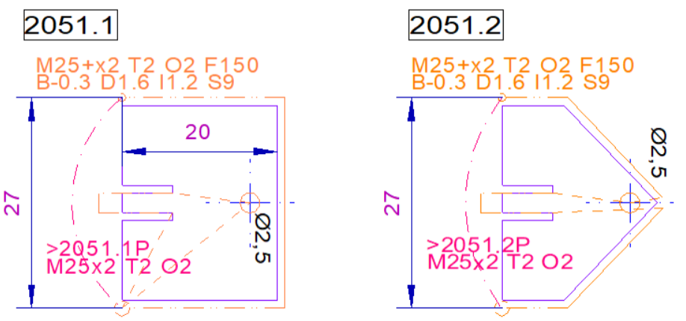
A “clamping project” for one rectangular and two pointed key handles could now look like this:
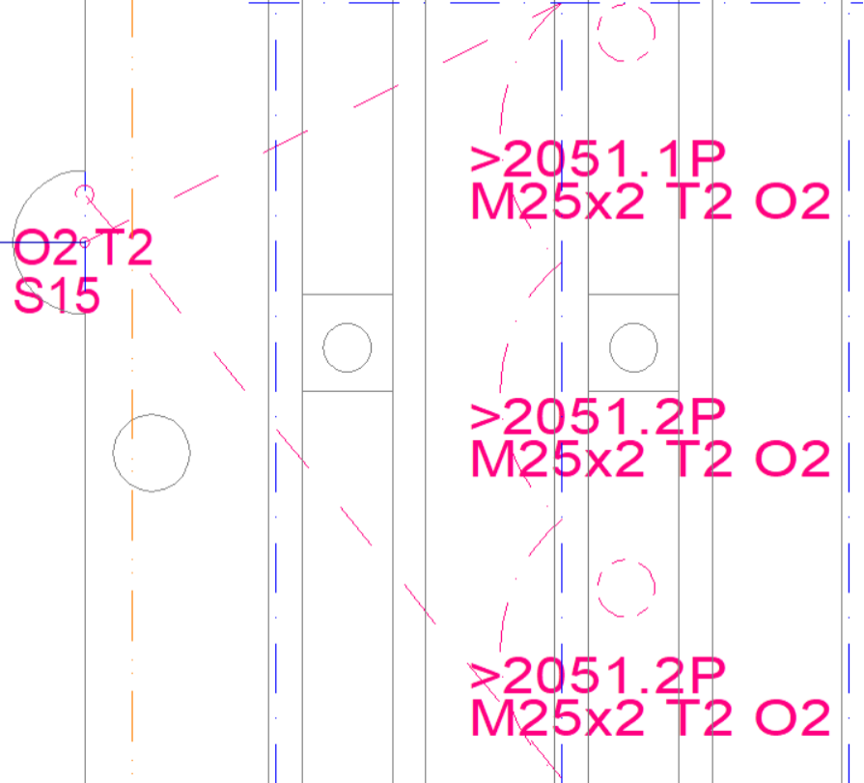
Now you might ask yourself whether you really want to mill exactly one 2051.1P and two 2051.2P here – in a follow-up job, you might need two rectangular handles and one pointed handle, or three pointed handles. Of course, you could copy the original project with the 1+2 handles and adjust the embedded paths in the copy – but it is preferable to design the details of the clamping project only once and then define the concreate variable assignments in a separate variables project so that changes to the clamping project do not have to be tracked in multiple places.
The solution for this is to have two separate projects:
- In the clamping project, the paths of the handles are no longer defined as fixed values, but are specified as variables.
- The clamping project defines at its start point which variables and which values are permissible.
- In a surrounding variables project, specific values are assigned to the variables.
- The names of the files generated from the variable project contain information about the variable values used.
The necessary texts are shown in the following:
Ad 1. In the clamping project, the embedded paths are specified using = variables,
Ad 2. the variables used and their possible values are defined at the starting point. The possible values here are P1 and P2, which are specified as comma-separated lists:

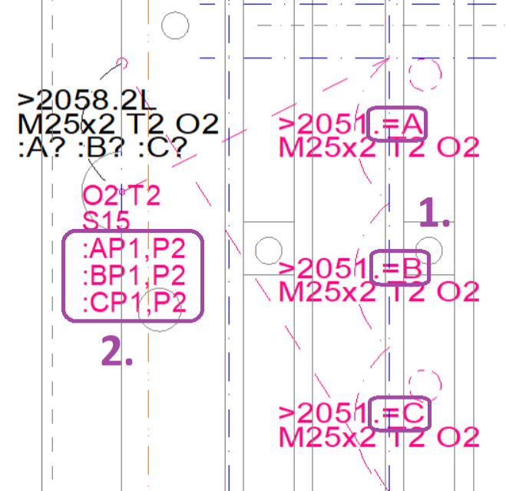
Ad 3. The variables project consists only of a call to the clamping project, where values are assigned to the variables:
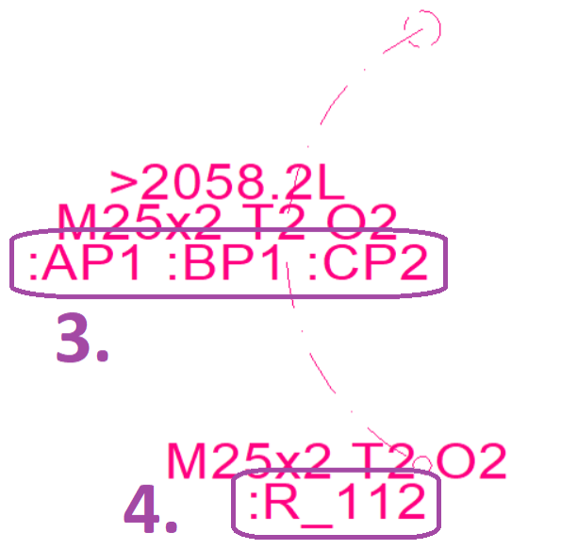

Ad 4. Using the R parameter, an arbitrary marker is added to the path of the variable project to provide information about the selected variable values in the file name. Here, this is the character string _112, which symbolizes the selected variable values P1, P1, P2.

4.2.16.2. Definition of variables
Variables are defined at the starting point of a path using text in the form
:<Name><Definition of permissible values>.
Name is a single character of your choice, but a letter should normally be used.
There are three ways to specify the permissible values:
a) Using a comma-separated list. Examples:
:AP1,P2,P3 means that the values P1, P2, and P3 are allowed for variable A.
:B2051.P1,2051.P2 means that the values 2051.P1 and 2052.P2 are allowed for variable B.
b) Using a list of individual characters after a question mark. Example:
:A?PQRS means that the values P, Q, and R are allowed for variable A (which could also be specified by :AP,Q,R,S).
c) via a range of numbers in the format from~to. Example:
:B-0.5~1.2 means that numbers between –0.5 and 1.2 (inclusive) are allowed for variable B.

4.2.16.3. Usage of variables
Within the path for which variables are defined, these can be used in any text by
=<Name>
e.g.
=A
If a variable is used that is not defined at the beginning of the path, an error message is displayed.
The values of the parameters N and O cannot contain variables. Specifications such as N=X or O=O, where :X1 or :O4 is then specified for the subpath element, are therefore not possible and result in an error message.

4.2.16.4. Setting the values
In a subpath embedding, the variables are assigned values, which are then used inside the subpath. For the assignment, the values are specified after the colon in the > text:
:<Name><Value>
e.g.
:A1,5
If a name is specified that is not defined in the subpath, or a value that does not match the definition of the permitted values, an error message is displayed.
The value of a variable can also contain variables that are passed from further outside the path. This is often done in the form :B=B, i.e., the variable B passed “down” (left B) is set to the value received “from above” (=B).

4.2.16.5. Check values for variables
If PathDxf2GCode is called with the /c option for paths with variables, variable values must be provided in order to generate correct path texts. The definitions of the permissible values are also used for this:
- If the permissible values are defined using comma or question mark lists, the first value of the first list, the second of the second list, the third of the third list, etc. are used as test values. If the list is shorter, the list is restarted from the beginning. The purpose of this procedure is to ensure that, even with similar lists (such as in the clamping project above), as many different values as possible are used for testing.
- For ranges of permissible values, the from and to values and the average of both are used in a round-robin fashion.

4.2.17. Star-shaped paths
Paths can also be “star-shaped”, i.e. they can continue from one point in several directions (with millings or sweeps). So that a unique path can be calculated in such cases, the segments of the paths can be annotated with N texts, e.g. N1, N2 etc. Segments without N are always traveled after the segments marked with N, with shorter segments being placed at the front. Boreholes and helix circles are always milled before all outgoing segments.
In some cases, the numbering with N is a little tricky because a segment connects to two star points. Here is such an example (constructed as a test case):
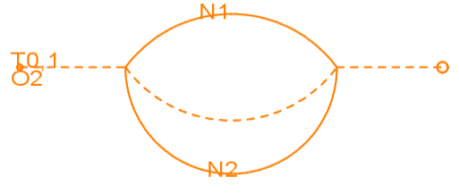
- After the sweep from the starting point to the left star point, the segment annotated with N1 is milled.
- When the right star point is reached, two sweeps without N could be taken (the straight one to the end point and the curved one to the left). However, the two milling movements annotated with N are tried first. Because the upper one has already been milled and is therefore ignored in the selection, the segment annotated with N2 is added to the path next.
- This milling run now reaches the star point on the left again. As both marked segments are now “used up” (because they have already been milled), the sweep in the middle is now selected.
- At the right star point, only the path to the end of the path remains.

4.3. Component path DXF files
The CAD drawing must be saved as a DXF file for reading by PathDxf2GCode. As PathDxf2GCode must later find the appropriate DXF file from the name of a component path in the project path drawing, each DXF file name must be able to provide information about the component paths it contains.
On p. 10, we saw that path names consist of distinct groups (for the default /n parameter, these would be three groups, a 4-digit number, another number and a trailing uppercase letter. If a path is search in DXF files, PathDxf2GCode identifies pathname patterns in each file name and matches them up with the searched path name. If the patterns match the path name, then the file is opened and scanned for the search path name. For this to work, the pathname patterns themselves must follow a specific pattern, which is defined by the /p option. Its default value is ([0-9]{4})(?:[.]([0-9]+))?, which allows the following pathname patterns:
- 4-digit number
- 4-digit number . number
e.g. 1234 or 1234.1 .
In detail, the pattern contains two “groups” separated by a dot; the second group including the dot is optional.
A DXF file name is now structured like this:
...pathname range{,pathname range...}....DXF
where a pathname range has one of the following two forms and meanings:
- Pathname pattern
  - The pathname pattern in the file name indicates that the file contains paths that match the specified groups. A pathname pattern 1234 with only one group thus indicates that the file contains paths such as 1234.3A, 1234.12L etc., i.e. paths whose first group is the same as the specified group 1234. A pathname pattern 1234.5 in the file name, on the other hand, indicates that this file contains paths like 1235.5P or 1234.5X.
- Pathname pattern–pathname pattern
  - Two path name patterns, separated by a minus sign.
  - Such a range indicates that the DXF file contains paths in this range. Groups are compared as numbers if they consist solely of digits; otherwise, they are compared as text. For example, a file with the name 1234-1236.DXF can contain the path 1234.8A, but also the path 1235.99B or any paths beginning with 1236. A file with the name 1234.5-1234.10.DXF—where the trailing group is numeric—may contain paths 1234.8A, 1234.5B and 1234.9A, but not the path 1234.40A.
The areas of the paths of different files may overlap, e.g. the files 1234.DXF and 1234,1235.DXF and 1230-1239,1241.DXF may exist at the same time. If PathDxf2GCode searches for a component path 1234.2P in this case, for example, it will read and search through all these files. However, if the path is found more than once, PathDxf2GCode issues an error message.
To locate subpath files, the following directories are searched:
- First the directory where the currently processed DXF file is located;
- then all directories specified via /d parameters (see p. 27).
The file name should be entered in the path drawing so that it is selected consistently with the drawing numbers during DXF export without much thought.

4.4. Projects

4.4.1. Project numbers
As mentioned, path drawings are created for projects. Projects are assigned drawing numbers from 8000 to 8999. Project numbers 8901...8999 are intended for test projects.

4.4.2. Project path drawings and subpaths
Project path drawings are drawn on a copy of the clamping and sacrificial plate. Such a drawing might look like this:
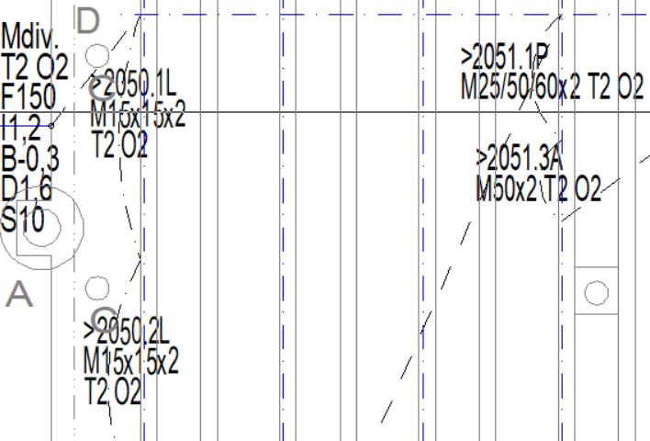
At least the following parameters must be specified for a project path:
- O, because the milling diameter for a project milling pass is fixed; and must be checked against the O specification in embedded paths;
- T, because for safety reasons it must always be clear from which depth drilling (G01) instead of an sweep (G00) is necessary for vertical runs.
- usually S, because project paths practically always contain sweeps whose height must be defined.
A project path drawing is constructed as follows:
a) Create a copy of the 1084 Ph drawing and rename it. The names of the project path drawings have the following form:
project-number.milling-pass
The milling passes are numbered and letters are added after the milling pass to identify the clamping and/or the milling cutter, e.g.
8001.1P and 8001.2P for two milling passes of different components
8002.1L and 8001.2R for two milling passes of the same components with clamping L and R
8003.1LS, 8003.2LT, 8003.3RT for three milling passes of the same components with
end mill (S) and then with T-slot milling cutter (T) for
left-hand clamping (L) and then with T-slot milling cutter for
right-hand clamping (R).
b) The subpath proxy lines (see p. 21) including the texts assigned to them (in particular the path names) of the components to be milled are placed. The start of a further component path can be placed at the end of the previous one if this is possible in terms of space and the profile.
- The proxy lines including text are copied from the component path drawings, but the start and end markings (1 and 2 mm circles) are not copied (reason: there may only be one start and one end marking in a path drawing).
c) Unconnected groups of paths are connected by sweeps (usually long-dashed lines).
d) The start point and end point at the far left are connected to the subpaths with sweeps.
e) The drawing is exported as a DXF file; the file name should be the same as the drawing name (e.g. 8001.1P.DXF). In addition, PDFs of the project path drawings should also be saved on the control computer of the milling machine, as they form the working document for clamping and unclamping the profiles and components and, if necessary, for replacing the milling cutter.

4.5. Z-Probes

4.5.1. Basics
I have a problem with the clamping on my milling machine: Even on the dressed clamping plate, the profiles do not lie in one plane, but are up to about half a millimeter lower or higher. This doesn't matter with fully milled profiles, but not with 3D milling, and especially not when a profile is reclamped and finish-milled from the other side. I have come up with the following aid for this:
- A path drawing can contain Z probe points at which the actual Z value is measured by a measuring run before the actual milling process (the milling cutter moves to the points with a G38.2; I have to record the displayed value manually by UGS in a text file).
- In the G-code file that PathDxf2GCode generates, a formula expression is stored for each Z-coordinate that describes the correction of the Z-value as a function of the measured values at the Z probe points.
- After the measurement run, another program called PathGCodeAdjustZ is used to “recalculate” the G-code file with the values from the text file and the formulas.
- I then carry out the milling process with this improved G-code file.
The entire workflow looks like this:
..._Clean.gcode
file
PathGCode-
AddZAdjusts
edited
..._Z.txt file
.DXF file
PathDXF2-
GCode
..._Milling.gcode
file
Empty ..._Z.txt
file

..._Probing.gcode
file
Measuring
run
Milling
run

4.5.2. Path drawing with Z probes
Z probe points are marked in the drawing by dash-double dash (DXF: PHANTOM) lines that emanate from a milling segment or subpath and end at the desired Z probe probing point. Their T and H values are taken from the connected segment (unless T and H are overridden on the Z probe line)PathDxf2GCode calculates the path for the measurement run in the _Probing.gcode file itself by always moving from the starting point to the next Z probe point that has not yet been visited; at the end, the program returns to the starting point.
The Z probes can be arranged in two ways:
- outside the profiles; in this case, the probe must be placed at the respective point during the measuring run.
- on a profile; in this case, a conductive contact between the profile and the probe must be established during the measurement run.
The following parameters can be specified at a Z probe:
- T: Sensor or material thickness in mm; if the specification is missing, it is taken from the connected segment.
- H: Additional height if the material is mounted on a support; if T is not specified, it is taken from the connected segment, if T is specified but H is missing, its default value is 0.
- L: name of Z probe; this is shown in the _Z.txt file so that one can identify the Z probe locations in addition to their coordinate position.
- Z: Measuring speed in mm/min; when missing, the Z value at the path start is used; if also this is missing, the /z option value is used.
Here is a path drawing that contains two such Z probes, each in the vicinity of subpaths; to recognize them more easily, they are drawn here as thicker lines:
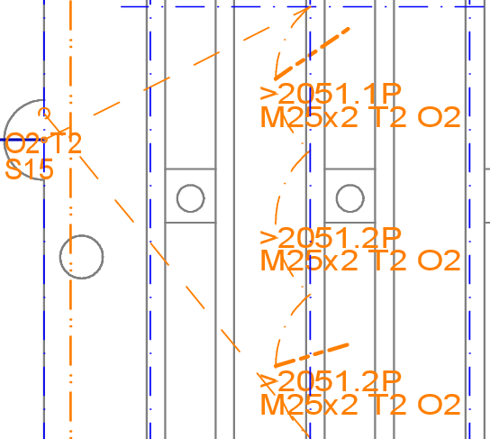

The resulting _Z.txt file looks like this:

([130.841 109.211]/T=2.000) #51=
([131.394 129.426]/T=2.000) #52=

4.5.3. Measuring run
For the measuring run, the milling cutter must be connected to one of the measuring connections. At the Z probe points, either the probe must be placed as described above or a conductive contact must be established between the profile and the probe.
After starting the _Probing.gcode file, the milling cutter moves to all Z probe points in the order in which they are noted in the _Z.txt file. If the milling cutter touches the probe or the profile, it stops for 4 seconds in each case so that the Z value can be transferred to the _Z.txt file. To do this, the Z value read in UGS is entered there manually, e.g. like this:
([130.841 109.211]/T=2.000) #51=2,1
([131.394 129.426]/T=2.000) #52=1.9
Both commas and periods are allowed as decimal points; spaces or tabs can be placed before and after the numbers.

4.5.4. Creating the _Milling.gcode file
A PathGCodeAdjustZ call (see p. 32) finally generates the final _Milling.gcode file from the _Clean.gcode and _Z.txt files.

4.6. Calling PathDxf2GCode

4.6.1. Command line options
All DXF files for which G-code files are to be generated are provided, together with three required parameters:
PathDxf2GCode /f150 /v1000 /s15 8001.27.1P.DXF 8001.27.2P.DXF
PathDxf2GCode stores the generated G-code files in the same directory as the transferred DXF files.
The following options can also be specified (see also p. 15):
/h Show options text
/f 000 Set default milling speed (F_xy) in mm/min; required
/g 000 Set default drilling speed (F_z) in mm/min; default is F_xy / 4
/j 000 Set default ramp angle in degrees; default is 10
/z 000 Set probing speed in mm/min; default is F_z or F_xy / 4 if F_z is not provided
/v 000 Provide maximum speed for sweeps in mm/min (for statistics only); required
/s 000 Set default sweep height in mm; required
/y 000 Set default clamp clearence in mm; no default (S used instead)
/c Check all paths in DXF file without writing GCode; if /c is not
provided the DXF file must contain only one path layer
/x zzz For all texts matching this regular expression, write assigned
DXF objects; this is helpful for debugging parameter texts
/d zzz Search path for references DXF files; can be specified multiple
times; default is the location of the DXF file
/n zzz Set regular expression for path names; default value is
([0-9]{4})[.]([0-9]+)([A-Z])
/p zzz Set regular expression for path patterns in file names; default is
([0-9]{4})(?:[.]([0-9]+))?
/l zzz Set output language; default is operating system language

Example calls:
PathDxf2GCode /h
PathDxf2GCode /f150 /v1000 /s15 /d..\Components “2913 Ph.DXF“
PathDxf2GCode /f 150 /v 1000 /s 15 /c /d ..\Components “2050-2051 P.1v.DXF“

4.6.2. Problems and their solutions

4.6.2.1. „Path definition … not found.“
Possible triggers:
- Starting point of a path not provided with line type “dash-double dash” (DXF: PHANTOM) → Solution: Provide starting point with line type “dash-double dash”.

4.6.2.2. „End marker missing.“
Reason: A path does not contain a valid end marker.
Possible triggers:
- End point of a path not provided with line type “dash-double dash” (DXF: PHANTOM) → Solution: Provide end point with line type “dash-double dash”.

4.6.2.3. “S value missing.”, “B value missing.”, ...
Reason: A segment cannot determine the required value.
Possible triggers:
- The value is neither defined at the start of the path nor at the segment → Solution: Define value.

4.6.2.4. „No further segments” at the specified point.“
Reason: No further segments connected at the specified point.
Possible triggers:
- End without continuation (e.g. two lines do not meet at a point; or a line does not end exactly at the center of a hole circle) → Solution: Find point in the drawing and connect lines and circle centers exactly to each other.
- Duplicate elements that lie exactly on top of each other; after traveling over one element and returning over the other “it doesn't go any further” → Solution: Remove duplicate elements.
- A line may not be in the path layer → Solution: Find the point in the drawing and move the line to the correct layer.
- Elements are used in the path that PathDxf2GCode does not support (e.g. splines) → Solution: Find the point in the drawing and replace elements from there with supported elements (see p. 15).

4.7. Calling PathGCodeAdjustZ

4.7.1. Command line options
In general, it is easiest to pass the _Z.txt file with the Z-probe heights to PathGCodeAdjustZ. The names of the associated _clean.gcode.txt file and the result file (_Milling.gcode file) are derived from this. Instead of the _Z.txt files, one can also specify the name of the _Clean.gcode file or even the DXF file from which the _Clean.gcode file was generated:
PathGCodeAdjustZ 8001.27.1P_Clean.gcode 8001.27.2P.DXF
The following options can also be specified:
/h Help text
/m 000 Maximum correction of Z values; required
/x zzz Regex for lines to be written to standard output
/l zzz Language

4.7.2. Maximum Z correction
In practice, it turned out that I would specify wrong T values for Z probes (especially when using the T value at the path start), for example T5 instead of T2. If the measuring run then returned a value of e.g. T=2.1 mm, the computed correction would be 5–2,1 = 2,9 mm, and the milling bit would thus dive almost 3 mm into the metal, and break off. To prevent this, one must specify a maximum Z correction. Typically, I use 0.9 mm, which hopefully spots all T value specifications off by a millimeter or more.

4.7.3. Emitting statistics lines
The Clean file contains at the very end useful statistics about the expected milling duration. Instead of looking there with an editor, it is possible to pass a regular expressio nto PathGCodeAdjustZ, which will output matching lines from the Clean file to the standard output. The statistics lines can be made visible there with /x mm.*min.

4.7.4. Problems and their solutions

4.7.4.1. “Line does not have the format ‘(comment) #...=value’”
Usually the values are missing after the equal signs.
If you want to mill without Z-adjustments, you can also send the respective _Clean.gcode file directly to the milling machine.

4.8. Milling run
For the milling process
- the generated G-code files
- and the associated PDFs of the path constructions (both project path constructions and component path constructions)
are transferred to the control computer of the milling machine.
The subsequent milling process is not described here.

5. Program documentation

5.1. Overview
PathDxf2GCode is essentially a 6-pass compiler written in C#, which transforms the DXF input into the G-code output in several phases. All 6 phases are run through completely for each input file; other files read in for embedded paths are only read once and then stored in a cache.
PathDxf2GCode's own code comprises approx. 1300 NLOC, that of PathGCodeAdjustZ approx. 150 NLOC. In addition, there is the (with 19000 NLOC much larger) netDxf library (see haplokuon/netDxf: .net dxf Reader-Writer (github.com)).

5.2. Github project
PathDxf2GCode is hosted on at https://github.com/hmmueller/PathDxf2GCode .

5.3. Compiler passes
The 6 passes are:
- DXF-Datei → DxfDocument; the netDxf library is used for this. The central method of this pass is DxfFile.LoadDxfDocument.
- DxfDocument → RawPathModel; RawPathModel is a temporary representation of the paths from a path drawing. Each path consists of
- path segments (types: MillSegment, SweepSegment, HelixSegment, DrillSegment and SubpathSegment),
  - where MillSegments have a MillingGeometry of type LineGeometry or ArcGeometry;
- Markers (start and end points)
- and path parameters.
The central method of this pass is PathModel.TransformDxf2PathModel.
- combining milling segments into milling chains; the central method for this is PathModel.CreatePathModel.
- PathModel → GCode-Liste; the central method of this text output is PathModel.EmitGCode together with the EmitGCode-methods in the GCode-hierarchy.
- Peephole optimizer of the GCode list (currently for summarizing consecutive sweeps); the central method for this is GCodeHelpers.Optimize, together with the Gcode-class hierarchy.
- output of the G-code file; the central methods are WriteGCodes and WriteZProbingGCode in the Program class, the AsString-methods of the Gcode-hierarchy and the WriteEmptyZ-methods.

5.4. Basic data structures
The following diagram shows examples of a helix, line, and arc segment and the most important objects associated with them:
netDxf-EntityObjects RawSegments Segments
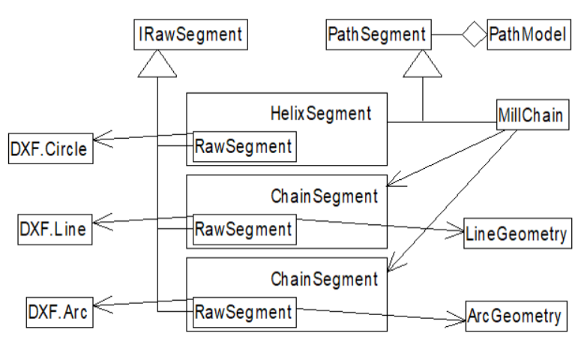

5.5. Special data structures and algorithms in PathDxf2GCode

5.5.1. GCodeHelpers.cs

5.5.1.1. Optimize
This method is a peephole optimizer for the generated GCode list. Patterns to be optimized are detected using regular expressions, for which each GCode object is represented by a character (propery Letter) .
- Currently, a peephole optimizer is implemented for the aggregation of subsequent sweeps (with comments in between).

5.5.2. MillGeometry.cs
MillGeometryHelper.CreateSupportBarGeometries
This methods creates the „ups and downs“ for support bars (see p. 20).

5.5.3. Params.cs
The ParamsText class is “raw”, meaning it contains the values before variable interpolation and can therefore be appended to the RawSegments. The interpolated values are stored in the Params classes.
Params-objects have a parent pointer:
- ChainParams, SweepParams, HelixParams, DrillParams, SubpathParams, ZProbeParams → PathParams
- MillParams → ChainParams

5.5.4. PathModel.cs

5.5.4.1. Inner class RawPathModel
Raw models read from a DXF file.

5.5.4.2. Inner class Collection
Cache for RawPathModels and PathModels.

5.5.4.3. CollectSegments
This is where
- the collection of all EntityObjects on paths
- the assignment of parameter texts to objects
- the evaluation of special markers (start, end, ZProbes)
- the loading of sub-paths
is done to create a RawPathModel.7

5.5.4.4. NearestOverlapping<T>, NearestOverlappingCircle, ….Line, ...Arc, CircleOverlapsLine, ...Arc, DistanceToArcCircle, GetOverlapSurrounding
Find objects for the assignment of parameter texts.

5.5.4.5. CreatePathModel
A. Linking the RawSegments to form a path
B. Generating the PathSegments
C. Building MillChains from consecutive ChainSegments (Mark and MillSegments)
D. Generating the parameter objects
E. Linking the SubpathSegments to the respective referenced model (which may be generated)

5.5.4.6. CollectAndOrderAllZProbes
A. Collect all ZProbes in the model and embedded models.
B. Sort the ZProbes into a reasonably short round trip.
C. Name the ZProbes on the round trip.

5.5.5. PathSegment.cs

5.5.5.1. Internal RawSegment classes
RawSegments and PathSegments are clearly separated. The former are not dependent on variable values, while the latter are. RawSegments are factories for their respective PathSegment objects. The classes are closely linked to each other via generic parameters and, where necessary, to their Params classes.

5.5.5.2. MillChain.EmitGCode
Edges are created in I-spacing for each segment of a MillChain. These edges are then run as close together as possible. If an edge connects at the same height, it is run next: Edges of one level are therefore usually milled before deeper layers are milled.

5.5.5.3. HelixSegment.EmitGCode
A helix is composed of semicircles, each of which moves down by I/2.

5.5.5.4. SubPathSegment.EmitGCode
A Transformation3 is created between the SubPathSegment and the referenced path, which converts the coordinates into the calling model.

5.5.6. Transformation2.cs
The angle between two vectors is only calculated in netDxf using the main branch of arccos. This always results in angle values between 0 and p, which is not correct. The only way I could think of to solve this was to perform a “rotation test”: rotate the first vector by arccos and -arccos and check which rotation actually results in the second vector.

5.5.7. Transformation3.cs
The Z-coordinate is not subjected to the usual transformation, but is adjusted using ZProbes.

5.6. Special data structures and algorithms in PathGCodeAdjustZ

5.6.1. ExprEval.cs
Simple LL(1) parser for a small subset of the G-code expressions used for the Z-adjustments. Both [...] and (...) are permitted as bracket pairs.

5.7. Currently known or suspected problems
None that would particularly bother me. See Github project for details.

5.8. Missing features
I plan to support parameterized path models soon.

6. Tables

6.1. Parameters

 | Meaning | Unit | Default value
A | Greatest diameter of helical circles | mm | 4 · O
B | Milling depth | mm
C | Comment | Text
D | Marking depth | mm
E | Allowed subpaths (reg. expression) | Text | /e
F | Horizontal milling speed | mm/min | /f
G | Vertical milling speed | mm/min | /g
H | Height | Mm | 0
I | Infeed | mm
J | Ramp angle | ° | /j
K
L | Name of a Z-Probe | Text
M | Material | Text
N | Sequence number
O | Milling bit diameter | mm
P | Support bar length | mm
Q | Comment written to G-code file | Text
R | Filename suffix | Text | none
S | Sweep height | mm | Project: /s  Subpaths: T+O
T | Material thickness | mm
U | Lower bound of support bar distance | mm
V
W | Top milling depth for „slow milling“ | mm
X
Y | Clamp clearence | mm | /y
Z | Z-Probe measuring speed | mm/min | /z
> | Subpath name | Text
. | Variable definitions and value assignments | Text
 | Sweep speed | mm/min | /v

6.2. Line types
Line type | AUTOCAD-Name | Meaning | Parameters
---------- | CONTINUOUS | Milling | N I F G B W J
- . . - . . - | DIVIDE | Marking | N I F G D W J
- - . - - . - - | BORDER | Milling with support bars | N I F G B D P U W
- - - - - - | DASHED | Sweep | N S Y
– – – – – | HIDDEN | Sweep without parameters
- . - . - . - . - | DASHDOT | Subpath | > M T O H C
‍……….. | DOT | Subpath as sweep | > M T O H C
– - - – - - – | PHANTOM | Special circles:  - Ø1 mm: Start  - Ø2 mm: End  Special line:  - Z probe | T O M B I F D U P S A W  T L Z H

I use the (old-fashioned) Becker-CAD 2D software, creating „classic“ two-dimensional projection drawings.
In Becker-CAD, layers are called „Folien“.
In Becker-CAD: „Folie“.
The letters are derived from the English words: T = Top; O is a diameter symbol; M = „Material“; F = „Feed“; I = „Infeed“; B = „Bottom“; D = „Depth“; S = „Sweep“; N = „Numbering“; P and U from „Support“.
My experience is that with F=150 mm/min, the deceleration of the milling head is so small that the milling bit goes into my aluminum pieces 0.3 mm or more. With F=50 mm/min, Z measurements are acceptable.
In BeckerCAD, a drawing is copied by re-opening the same MOD file and then selecting the drawing with „Hinzufügen“ („Add“). Afterwards, one must manually rename the drawing.
In BeckerCAD, in the component path drawing, create a copy of the proxy lines outside the drawing, select these copies and transfer them to the project path drawing with „Selektieren → Selektierte Elemente einfügen“; finally, move these copies to the correct position in the project path drawing.
In BeckerCAD, one can find the problem location as follows: Select „Point“ drawing, then move the mouse or enter the coordinates in the entry dialog.

